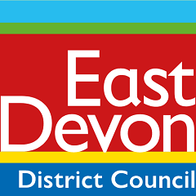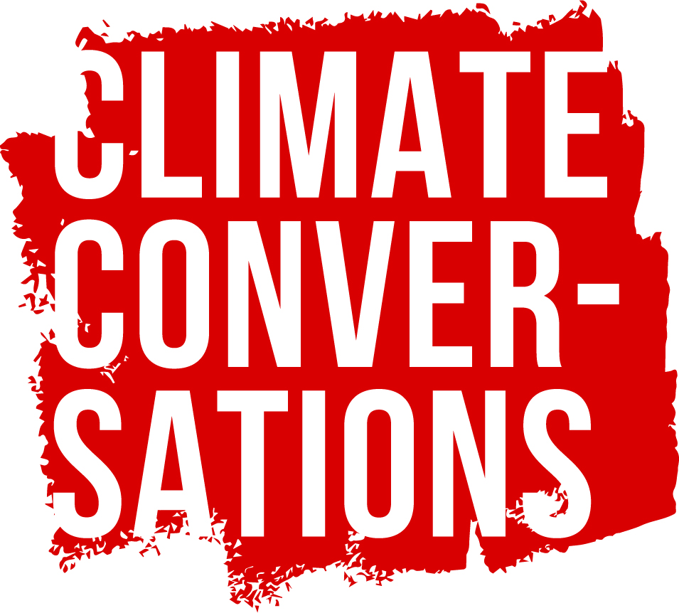

THG Climate Change Strategy 2024

As part of East Devon District Council our vision is to become net zero by 2040, working within a low carbon economy and lifestyle. This will be reflected in our travel, homes, businesses, visitor experiences and communities.

The University of Exeter has calculated the current carbon emissions of East Devon District Council. This information was used to inform the content of our Climate Change Strategy and action plan by giving us a starting point for our objective to reduce carbon emissions and work towards becoming a carbon neutral council.

The total gross emissions in 2022/23 across EDDC were 36,249 tCO2e

Our Priorities

• Increase resilience to climate change to maintain East Devon as a safe and healthy place to live, work and visit
. • Enable reductions in greenhouse gas emissions from energy consumption in homes, transport, and businesses in East Devon.
• Enable the development of secure supplies of renewable and low carbon energy for individuals, communities, business and industry.
• Support new development which seeks to minimise additional associated greenhouse gas emissions.
• Contribute towards developing the low carbon economy

What is THG doing?

We use Julie’s Bicycle Creative Green Tools to measure the impact of our programme; measuring energy use, water consumption, waste generation and recycling, travel and production materials.

THG’s success will be measured by comparing carbon emissions across our annual changing programme, analyzing reduction rates.

Our Engagement Officer has recently become a Carbon Literacy Facilitator. All staff and some volunteers are now Carbon Literacy trained.

Programme
- We commit to raising awareness of climate and ecological emergency through our programme. THG’s Climate Conversations programme spearheads EDDC’s climate behavioural change work through arts and culture. Climate Conversations bring different perspectives and new opportunities, helping us understand and adapt to our changing planet.

- Adapting the ways in which we curate, install and de-install exhibitions and shop display.
- Borrowing artworks from fewer locations
- Reviewing the length of our exhibitions
- Using enhanced communication to support the installation of artwork and activities further reducing the need for business travel.

People, collaboration and partnership
We commit to working in partnership with other arts organisations to support sustainability initiatives and working collaboration with community organisations across East Devon. We share guidance issued by EDDC’s Events Team which details specific actions which can be taken to support sustainability.
We are committed to informing our visitors of our sustainability work and will publish our results on our website.
We are committed to learning how to make sustainable choices through Carbon Literacy training for staff and volunteers.
The statement will be reviewed in 2025

